Government of the People’s Republic of Bangladesh
Ministry of Finance
Economic Relations Division
Japan-2 Branch
www.erd.gov.bd

PRESS RELEASE

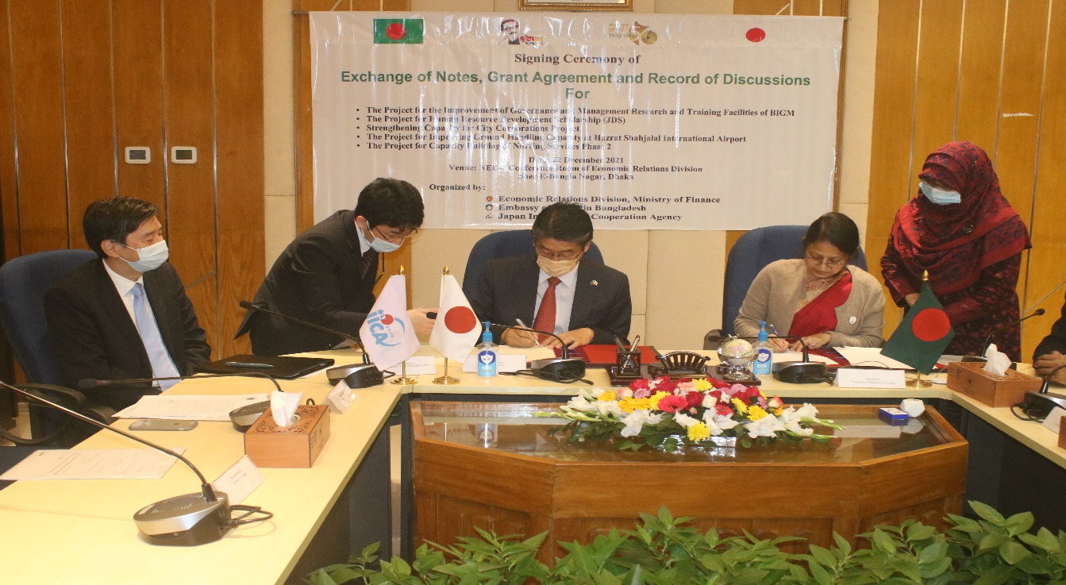

The Government of Japan will provide an amount of 462 million Japanese Yen (equivalent to approximately Taka 35.75 crore or USD 4.21 million) for the project titled 'The Project for Human Resource Development Scholarship (JDS)' as Grant for Year 2021 and 2,429 million Japanese Yen (equivalent to approximately Taka 194.32 crore or USD 23.00 million) for the project titled ‘The Project for the Improvement of Governance and Management Research and Training Facilities’. ‘Exchange of Notes’ and ‘Grant Agreements’ in this regard have been signed today on 22 December, 2021 between the Government of Bangladesh and the Government of Japan. Ms. Fatima Yasmin, Secretary, Economic Relations Division (ERD), Ministry of Finance has signed the ‘Exchange of Notes’ and the ‘Grant Agreements’ on behalf of the Government of Bangladesh, while His Excellency Mr. Ito Naoki, Ambassador of Japan in Bangladesh has signed the ‘Exchange of Notes’ and Mr. Yuho Hayakawa, Chief Representative, JICA Bangladesh Office, Dhaka has signed the ‘Grant Agreements’ on behalf of the Government of Japan.

'The Project for Human Resource Development Scholarship (JDS)' is being implemented during the period 2001-2025 by the Economic Relations Division. Under the project, the grant provided by Government of Japan is being utilized for Scholarships for BCS Cadre Officers, Bangladesh Judicial Service Officers and First Class Officers of Bangladesh Bank
Please Turn Over
to study Masters and PhD courses at various universities in Japan. This scholarship is contributing to develop knowledge and skills acquired through higher education from Japanese universities; moreover, it is helping to develop relations between the two countries. Total 385 (383 for Masters Degrees and 2 for PhD) officers have achieved Masters Degrees from Japan till date under this project. At present 68 (59 for Masters Degrees and 9 for PhD) officers are studying in Japan and 33 (30 for Masters Degrees and 3 for PhD) officers have been selected for studying in Japan in the last batch. It is to be noted that earlier Government of Japan has provided 6.8 billion (approximately) Japanese Yen as grant for implementing the project for the period 2001-2020.

Grant provided by Government of Japan for ‘The Project for the Improvement of Governance and Management Research and Training Facilities’ will be utilized for developing physical infrastructure for training and research in BIGM to enhance the physical infrastructure facilities of BIGM, and to establish specialized centers for joint education, training and research activities on good governance, management and development in Bangladesh and Japan. The project will be implemented by Bangladesh Institute of Governance and Management (BIGM) under Ministry of Public Administration. Implementation period of the project is April 2021 to June 2023.

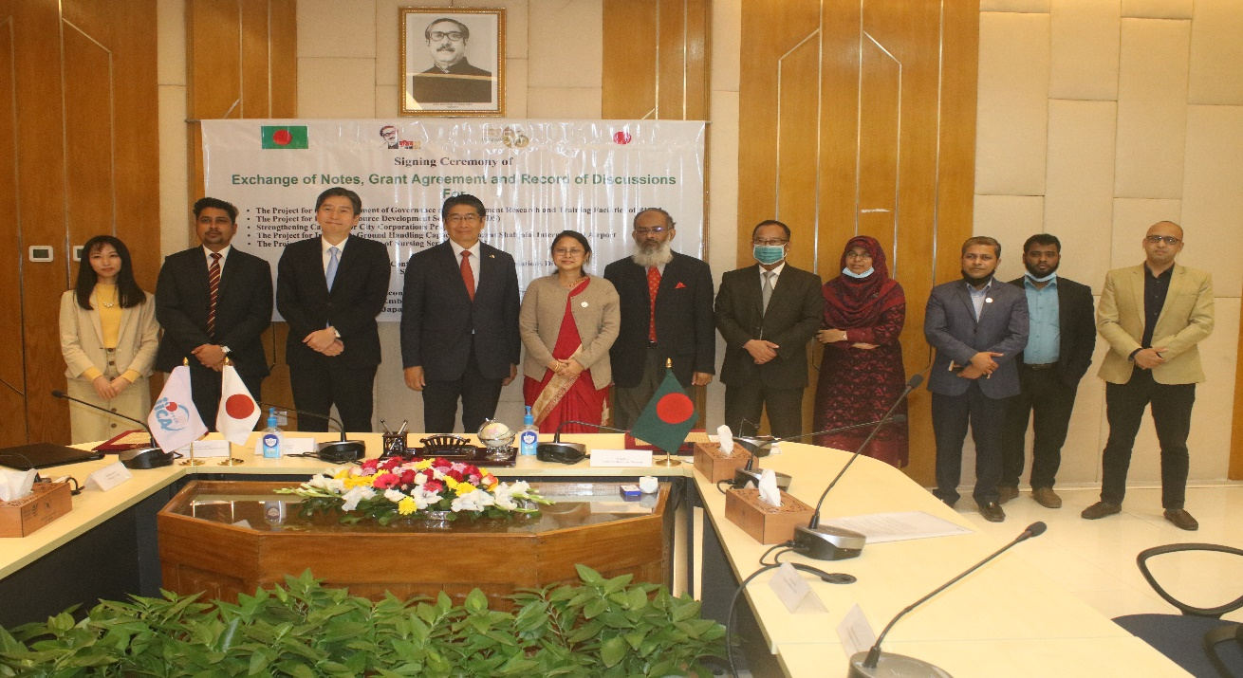

Besides above two grant agreements, Record of Discussions (R/D) of three projects under technical cooperation have also been signed today. These three projects are ‘Strengthening Capacity for City Corporations Project’, ‘The Project for Improving Ground Handling Capacity at Hazrat Shahjalal International Airport’, and ‘The Project for Capacity Building of Nursing Services Phase 2’, which will be implemented by the Local Government Division (LGD), Ministry of Civil Aviation and Tourism, and Medical Education and Family Welfare Division respectively.

Through ‘Strengthening Capacity for City Corporations Project’ administrative functions in city corporations will be strengthened, which will contribute to improve service delivery of city corporations. Purpose of ‘The Project for Improving Ground Handling Capacity at Hazrat Shahjalal International Airport’ is to improve convenience, efficiency and safety at Hazrat Shahjalal International Airport by providing sustainable ground handling services. On the other hand, through ‘The Project for Capacity Building of Nursing

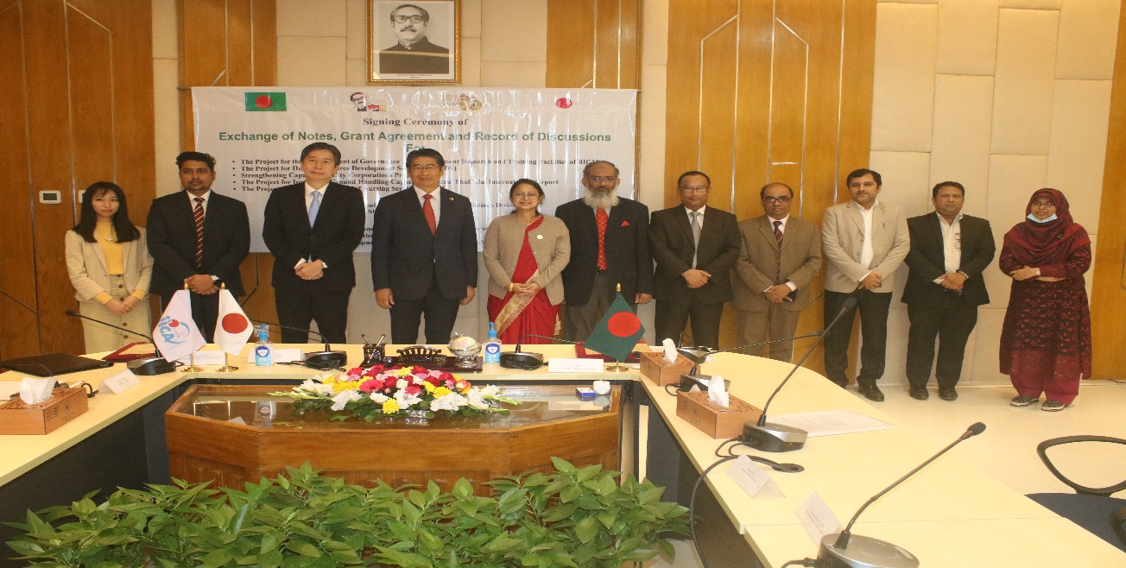

Services Phase 2’ implementation system of nursing education will be strengthened at the targeted public nursing colleges and hospitals.

Japan is the single largest bilateral development partner providing financial support for the socio-economic development of Bangladesh. Till November 2021, the support commitment has exceeded USD 27.40 billion and disbursement to USD 16.18 billion Japanese loans and grants are being utilized in a wide range of areas including power, roads, bridges, telecommunication, agriculture, health, education, water supply and sanitation, rural development, environment, human resource development etc. The Japanese assistance contributed significantly in overall development of the country.

Fatema Begum
Deputy Secretary

